Getting Started
In this lesson, you will write a personal reflection in which you share a personal experience.
There are a lot of situations in our lives where we stumble into moments that are humorous or teach us something. Even if it at first the moment feels embarrassing or stressful, looking back we see that it makes a funny story or that we learned something.
You will write about one of these moments in your life.
Let’s get started.

In this section,
you will learn
to do the following:
- Write a personal reflection based on autobiographical events and using digital media, and then evaluate the essay using a rubric
- Use effective techniques, choice of detail, and appropriately structured sequence of events to develop personal reflection

Prewriting—Create a Timeline
Being able to see the humor or lesson in a situation is healthy. The comedian Bob Newhart said, “Laughter gives us distance. It allows us to step back from an event, deal with it, and then move on.”
You will write a personal reflection on an experience in your life. Think of an experience you had that, after reflecting on it, you can see something humorous or something you had learned.
To help you put your thoughts on paper, create a timeline. As you remember events related to your experience, place them on the timeline in the order they happened.
Move through the activity to learn about using a timeline.
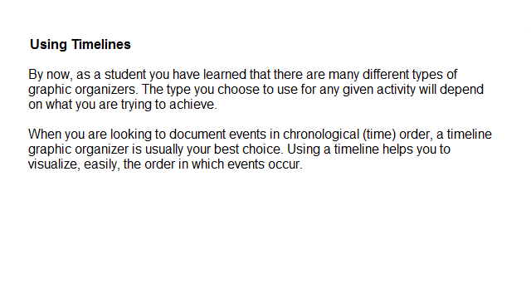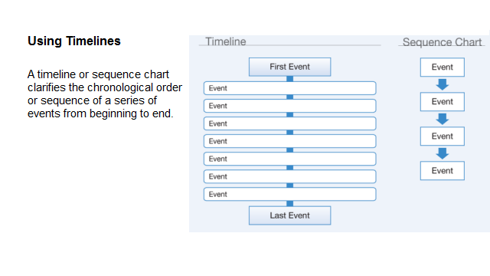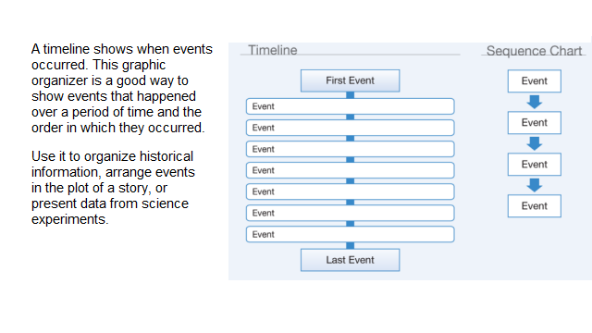Now watch this video on personality and emotions. As you watch, keep in mind the experience you will write about. Think about your own personality and emotions, and those of anyone else who was there.
Reflect on these questions about your personal experience:
- How did you respond to the experience at the time?
- How did your personality or emotions improve or worsen the situation?
- Did another person’s personality or emotions improve or worsen the situation?
Click Play to view the video.
After thinking about what you have learned from the video, what are some better ways you could have responded to the events?

Conduct Internet Research
There is an old saying that “laughter is the best medicine.” A good joke or funny incident can pull us out of a bad mood or turn around a difficult situation. It can even contribute to our health.
Read some articles on the Internet about the health benefits of humor. Two such articles are: “Humor Helps Your Heart? How?” on the American Heart Association website (www.heart.org) and “Laughter Is Important for Wellness” on the U.S. Department of Veterans Affairs website (www.va.gov). Go to the Student Resources page. Look for this writing activity to locate the hyperlinks.
Take notes and organize your information on your timeline.
For each Internet article, make sure you write down the following information:
- URL (or web address)
- Website title
- Web page title (title of the article)
- Author
- Date of publication or update
- Organization or publisher
- Date you read the article online
You will need this information if you include any information from the sources you read in your essay.

Drafting—Write Your Personal Reflection
You are now ready to write your essay. Move through the activity to see how to structure your essay.
Also, cite any source that you have quoted or paraphrased.
If you have cited a source, at the end of your essay, include a “Works Cited” page. Use Modern Language Association (MLA) style. (If you are unfamiliar with this style, consult the Internet or another source to help you format this page.)

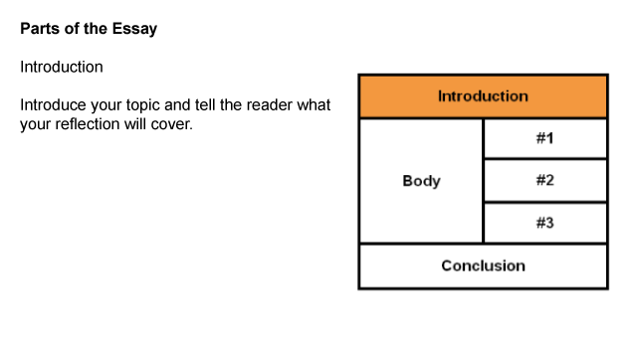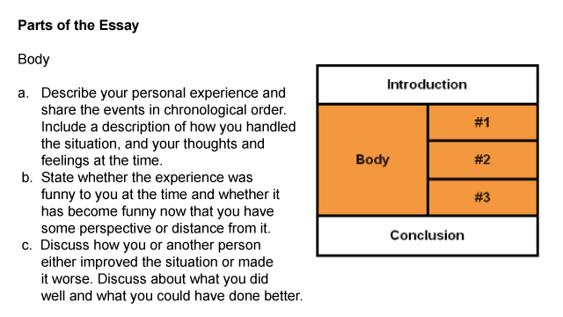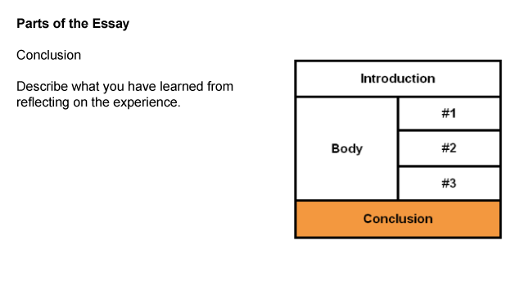Revising, Editing, and Proofreading Your Work
Now that you have written your first draft, you are ready to revise, proofread, and edit your work so that it will be ready to turn in.
Revising—Review your draft to find ways to improve your writing. Make sure that you have made smooth transitions between events and used transitional words such as first, second, next, and finally. Also, if you have cited any sources, make sure you have created a “Works Cited” page and that you have used correct formatting.
Editing and Proofreading—To make your writing error-free, check spelling, punctuation, and grammar.
After you are done with this step, use the rubric on the next screen to help you evaluate your work.
Use this rubric to evaluate your work. Scores range from 4 to 1, with 4 being the best.
When you are finished, submit your work to your teacher.
